Thesis/Dissertation Title

A thesis/dissertation submitted in partial fulfillment
of the requirements for the degree of
Master of Science in Materials Science and Engineering <or>
Doctor of Philosophy in Materials Science and Engineering

by

My Name
Name of University
Bachelor of Science in Physics, 2000
Name of University (even if same as 1st)
Bachelor of Science in Electrical Engineering, 2004

Graduation Month Year
University of Arkansas

This thesis/dissertation is approved for recommendation to the Graduate Council.

Typical Professor, Ph.D.
Dissertation Director

Committee Professor, M.S. |  | Committee Professor, Jr., Ph.D.
Committee Member |  | Committee Member

Committee Professor III, Ph.D. |  | Ex-Officio Member, Ph.D.
Committee Member |  | Ex-Officio Member

The following signatories attest that all software used in this thesis/dissertation was legally licensed for use by Student Name for research purposes and publication.

__________________________________ __________________________________

Ms. Student Name, Student Dr. Major Professor, Thesis/Dissertation Director

This thesis/dissertation was submitted to http://www.turnitin.com for plagiarism review by the TurnItIn company’s software. The signatories have examined the report on this thesis/dissertation that was returned by TurnItIn and attest that, in their opinion, the items highlighted by the software are incidental to common usage and are not plagiarized material.

__________________________________ __________________________________

Dr. Rick Wise, Program Director Dr. Major Professor, Thesis/Dissertation Director

Abstract

The abstract for a master’s thesis/dissertation should be double spaced. There is no actual page number on the abstract.

Acknowledgements

Firstly, I would like to thank Professor Ken Vickers for kicking my a.. when needed to encourage me to perform to the best of my abilities (especially in the attention to making this document a professional looking document that I will be proud to point to five years from now).
The MSEN program would like to thank Cohort 4 student Matt Kelley for his hard work in creating this template document for our students. It was created using Office 2003, but has been largely modified for Office 365 software. At Matt noted in his last email to Prof. Vickers on the subject on September 19, 2008,
“Attached is the updated template. I spent way too much time trying to change the autoformatting of figure numbers and ended up breaking functionality, so I reverted to an earlier version. To make the figures number by chapter.fig# one has to use "bullets and numbering" to autoupdate the chapter number by defining a numbering style of "Chapter <#>:<indent afterwards>" and then create a template for the figure numbering as well. I have the directions on how to do it, but I think that it is more important to get a new version up, and I will go back and make the changes when I have more time.”

Note: While we have tried to keep this current to the Graduate School Guidelines, always download their current guide from http://grad.uark.edu and follow their instructions.

Dedication

This edition of the Thesis/Dissertation template is dedicated to all graduate students at the University of Arkansas.

Table of Contents

Chapter 1: Do’s and Don’ts 1
Chapter 2: Setting Styles 9
Chapter 3: Sub-Chapters, Tables, and References 11
3.1 Sub-Chapters and Tables 11
3.2 References 11
Chapter 4: Figures 14
4.1 Inserting Figures 14
4.2 Second Subsection 14
Chapter 5: Final Comments 15
5.1 Updating Table of Contents, List of Figures, List of Tables, and References 15
5.2 Inserting MS Project File 15
References 17
Appendix A: Description of Research for Popular Publication 18
Appendix B: Executive Summary of Newly Created Intellectual Property 20
Appendix C: Potential Patent and Commercialization Aspects of listed Intellectual
Property Items 21

C.1 Patentability of Intellectual Property (Could Each Item be Patented) 21
C.2 Commercialization Prospects (Should Each Item Be Patented) 22
C.3 Possible Prior Disclosure of IP 22
Appendix D: Broader Impact of Research 25
D.1 Applicability of Research Methods to Other Problems 25
D.2 Impact of Research Results on U.S. and Global Society 25
D.3 Impact of Research Results on the Environment 26
Appendix E: Microsoft Project for MS MicroEP Degree Plan 27
Appendix F: Identification of All Software Used in Research and Thesis/
Dissertation Generation 28

Appendix G: All Publications Published, Submitted and Planned………………………29
List of Figures

Figure 2.1: Styles selection pull-down menu in Word 2003 9
Figure 2.2: Style ribbon option in Word 2007 9
Figure 2.3: Modifying styles in Word 2003 and 2007 10
Figure 2.2.1: Navigation buttons 12
Figure 2.2.2: Word 2007’s reference functions 13
Figure 4.1.1: Electromagnetic spectrum. 14

List of Tables

Table 3.1.1: Test table 1. 11

Chapter 1: Do’s and Don’ts

The following text was directly copied from the MSEN Graduate Student Handbook, 2020, and originally authored by Prof. Ken Vickers. The use of this text is specifically authorized by Prof. Vickers. Before beginning writing your thesis please confirm that you are using the most current Graduate Student Handbook revision.
*****REPRINTED*****
- Read the entire Thesis/Dissertation Writing Guide on the Graduate School website grad.uark.edu. Check every item against your template before you start adding significant content. Do NOT use old MSEN thesis/dissertations as a model.

- Read the prior page in this handbook again. No thesis or dissertation will be approved without all required appendices done with the same professionalism as the rest of the document.

- Electronic Files
  - Keep your work in a single electronic file from the start - it will save you heartache at the end.
  - Always start an editing session by doing a “Save as” command as a new revision number.
  - Always end an editing session by saving your new revision in at least three different physical locations.

- Naming Convention – Use the correct word for your document
  - M.S. work is contained in a “Thesis”
  - Ph.D. work is contained in a “Dissertation”

- Acknowledgements of funding and support
  - If your work has been funded by the NSF, use the following language at the end of your acknowledgements “This program is financially supported by the National Science Foundation under Grant No. xxx-nnnnnnn. Any opinions, findings, and conclusions or recommendations expressed in this material are those of the author and do not necessarily reflect the views of the National Science Foundation.”
  - If you work included work done in HiDEC, use the following language “Research possible through the use of the High Density Electronics Center at the University of Arkansas, Fayetteville campus“. Use similar language if you did a major element of your work in a lab other than that of your major professor.
  - Consider whether you should specifically recognize a staff person who has given you significant help in executing some design or fabrication element of your work.

- References
  - Must be in one combined list at the end of the document rather than at the end of each chapter.
  - Must appear in numerical order as they appear from front to back of your thesis or dissertation.
  - References used in an appendix are listed at the end of that appendix.
  - If you use a web URL as a reference (not a recommended practice) then the hyperlink must be removed and the date you accessed the information must be included.
  - Do NOT use any Wikipedia reference.

- Graphs (note that all comments in Section 12 – Figures may also apply to graphs)
  - Use clear backgrounds, not the default gray in Microsoft Excel.
  - Use both lines and symbol styles, not just color changes, to display different data sets.
  - Use the same format on titles, figure captions, graph axis, etc throughout paper.
  - Expand axis of dependent variable by using portrait layout instead of the default landscape format in Word (increase physical size of Y axis to increase ability to separate data points).
  - Most experimental data should use XY scatter style graphs, not the default Excel style with data displayed in even increments along the X axis.
  - When creating a graph in Excel, always create the graph on a separate page (the last option step in the graph wizard). Make the graph look good on that page, then copy it to the clipboard. Use the Paste Special option to put it into your document as a picture. Format the picture under advanced layout to force text lines to be only above and below it, which will then allow you to size the graph as needed and the text will scale with the graph.
  - Don’t wrap text around a figure. This works well in some journal formats, but in a thesis or dissertation it makes the figure difficult to see and often results in text that is difficult to read.
  - Grow all graphs proportionally to full page width unless it reduces clarity of your graph.

- Formatting Issues
  - Chemistry style dissertations of combined published articles can only allowed if your major professor first formally applies for approval to the Graduate Studies Committee of microEP six months prior to your defense date. The GSCMEP will discuss the pros and cons of this approach with the professor and student, and only if approved will the dissertation be allowed. Any dissertation that is submitted in this format without six month prior approval will be rejected and will be required to be re-written in standard format.
  - Use third person past tense.
  - Experiments were in the past – always use past tense verbs when describing your completed work.
  - No footnotes are allowed.
  - All page numbers must be right aligned in the table of contents, list of figures, list of tables, etc.
  - Page numbers preferred at bottom, not top right. The page number must touch a line drawn 0.75 inches from the bottom of the page to be acceptably placed.
  - No italics, bold, or whatever can be used in the body text to make a point. Use of these techniques may be good in a proposal, but are bad in a thesis or dissertation.
  - Buy your good cotton paper early in the semester, as they do run out sometimes at the end.
  - When printing, make sure the watermark is upright and readable from the front of your printed page.
  - Use no qualitative terms, only quantitative comparisons.
    - Correct: Within 10%, 10 times greater, less than 10 years, both were square but of different color, etc
    - Wrong: Words such as almost, significantly, close, similar, etc
  - Titles of your thesis/dissertation must be in “Title Case”.
  - When referring to figures, chapters, tables, sections, etc. in the text body, the item is considered a proper noun that should be capitalized and spelled in full (Figures x.x, Equation x.x, Chapter Two, etc.)
  - Titles of chapters, sections, etc. should be Times New Roman Size 12.
  - Font style must remain the same for ALL elements of your thesis/dissertation.

- Equations
  - Should be outside the text body on a separate line.
  - Should be labeled with (Equation X) right justified against right margin on the same line.
  - Variables in the equation must have the exact font style and size when used in the body text as was shown in the numbered equation. This includes such things as italics.

- Numbers
  - Only display the correct number of significant digits.

- Statistics and variation
  - Always indicate variation in data by error bars on and data point graphed that contains consolidated data.
  - Consider if all data should be included on graph if each data point would only consolidate a few number of points – making the concept of average and standard deviation meaningless. Remember that for standard deviation to be valid you must have a normal distribution (at least 30 data points). Consider using “box and whiskers” for smaller data sets.

- Figures
  - Must be directly after mention in text (within a couple of lines) if at all possible – without generating white space.
  - Figures must be mentioned in text.
  - Figures placed in landscape mode always have their tops to the left (toward the binding).
  - Captions in a text box that is grouped with the image will not cause a problem when the figure is shifted. Use of the “insert caption” option is preferred to support automatic generation of Lists of Figures.
    - Correct: captions need to be grouped with the picture
    - Wrong: text going to the next page
  - If you have scanned a figure from a reference to include in your document, the scan quality must be high enough resolution to match your document. Use the “Paste Special” to paste it as different kinds of objects/pictures to see which looks best and include the reference number in the caption.
  - A figure must be fully contained on one page.
  - Captions should only label the figure. Descriptive text must be in the body text.

- Tables
  - Must be directly after mention in text (within a couple of lines) if at all possible – without generating white space.
  - Tables must be mentioned in text.
  - Tables may be rotated 90 degrees if needed, but top of table is to the left (toward the binding).
  - Text in cells is usually left justified unless it is text labeling a column of numbers. Then the numbers and the label should be right justified. If the numbers contain a decimal point, always use the same number of decimal points on each number and be sure you properly represent the proper accuracy and repeatability of your measurements).

- Presentations
  - Your presentation must be reviewed and approved by your major professor before making your public presentation a week before your thesis or dissertation defense.
  - There should be a footer on each page outside of your content area that contains “Name, Date, and Slide n/Total Number”.
  - Always test your color scheme using a projector for readability from the back of the room. For instance, red letters on dark blue background look OK on the computer screen but cannot be read when projected on a screen during your defense.
  - Label all figures used in your presentation with the figure number used in the thesis or dissertation.

- Signoff Page
  - The Director of the MSEN Graduate Program is an ex-officio member of the thesis and/or dissertation committee of each MSEN student. His or her name should be included on the signature page as a committee member.
  - Bring all needed copies of the signoff page, plus extra cotton and paper pages, to your defense.

Chapter 2: Setting Styles

To make a new chapter, the style of the chapter title text must be “Heading 1.” Select the text for the heading, and choose the “Heading 1” style, see Fig. 2.1 for the Style ribbon in Word 365. The new requirement for headings is that they be no larger the body text, but you can use bold or italics if you wish.
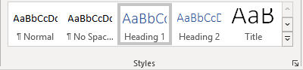
Figure 2.1. Styles ribbon option in Word 365.

This paragraph text has the style “Body Text Indent.” The styles in Word 365 can be modified by right clicking on the name of the style in the ribbon, and choose Modify, see Fig. 2.2. To start a new chapter, Choose Insert > Break… from the pull-down menus, and select “Page Break” from the “Break types” option.
Figure 2.2. Modifying styles in Word 365.

Chapter 3: Sub-Chapters, Tables, and References

3.1 Sub-Chapters and Tables

Notice that there is now a sub-chapter. This style is set to “Heading 2.” The sub-chapter will indent in the Table of Contents. To have sub-sub-chapters, set the style to “Heading 3.” Each successive heading will indent further within the Table of Contents.
Now it’s time to add a table. Look below at Table 3.1.1.

Table 3.1.1. Test table 1.
Column 1 | Column 2
A | 1
B | 2
C | 3
D | 4
E | 5
F | 6
G | 7

Notice that the style of the table title is “Table.” Setting the style “Table” will make the table label text appear in the List of Tables along with its page number.

3.2 References

There are two distinct methods for efficiently citing references in Word: using the built-in feature or a third-party add-on, such as RefWorks or EndNote. Using one of these two methods to add and manage references is a lot easier that trying to do them manually. RefWorks is available free of use to students and is web based, so your references are available to you wherever you have internet access.

The built-in references manager in Word 365 is a great improvement over the rudimentary implementation in previous versions of Microsoft Word. Word 365 manages citations much more efficiently that its predecessors, but the citation lists are not as easily imported and exported. Compendex and IEEE Xplore are able to export search results directly to BibTeX, RefWorks, EndNote, ProCite, and the various other reference manager formats, but currently they do not support Word. To access Word 365’s references features, select the “References” ribbon to expose the options for inserting and managing references, as shown in Fig 3.2.1.
Figure 3.2.1. Word 365’s reference functions.

Chapter 4: Figures

4.1 Inserting Figures

Just like when you insert a table, you must set the figure text style to “figure.” Figure 4.1.1 shows the electromagnetic spectrum.
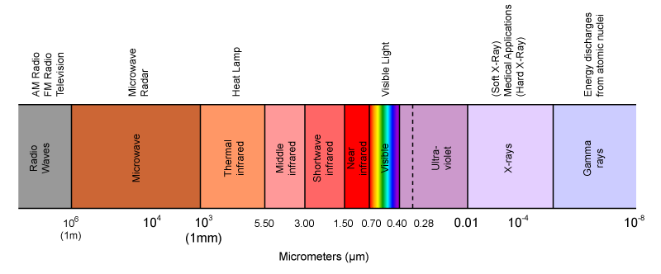
Figure 4.1.1. Electromagnetic spectrum.

4.2 Second Subsection

This is to remind you that you should not ever have a single subsection. If there is only one topic, include it in that body of text instead of a single subsection.

Chapter 5: Final Comments

5.1 Updating Table of Contents, List of Figures, List of Tables, and References

Press Ctrl+A to select the entire document. Press F9 to auto-update the TOC, LOF, LOT, and numbered references within the thesis. Sometimes a dialog box will appear asking what needs to be updated. “Update page numbers only” and “Update entire table” are presented as choices. Choose “Update entire table.”

5.2 Inserting MS Project File

Use the camera icon to capture a gif image of sections of your MS Project file, designating a start time as the first day of one quarter (1/1/xx, 4/1/xx, 7/1/xx, or 10/1/xx) and the stop time as the last day of one quarter (3/31/xx, 6/30/xx, 9/31/xx, or 12/31/xx).
Before clicking the camera icon you should do several things to set the captured image for maximum effectiveness in your appendix.
- Right click on the first column header cell (the “I” column) and hide the column.
- Expand the “Task Name” column to fully display your task names.
- Set time magnification to fully display your full project (usually 2-3 years for a MS and 3-5 years for a PhD project).
- Move the Gantt chart left edge to the middle of the “Duration” column.
- In the Task Menu, click arrow head beside Copy.
- Click “Copy Picture.” (circled in picture below)
- In the Dialog box, click “As shown in figure.” (circled in picture below)
- “For screen” copies the image into the clip board, “For Gif image” saves image as .gif image.
- Click “OK.”
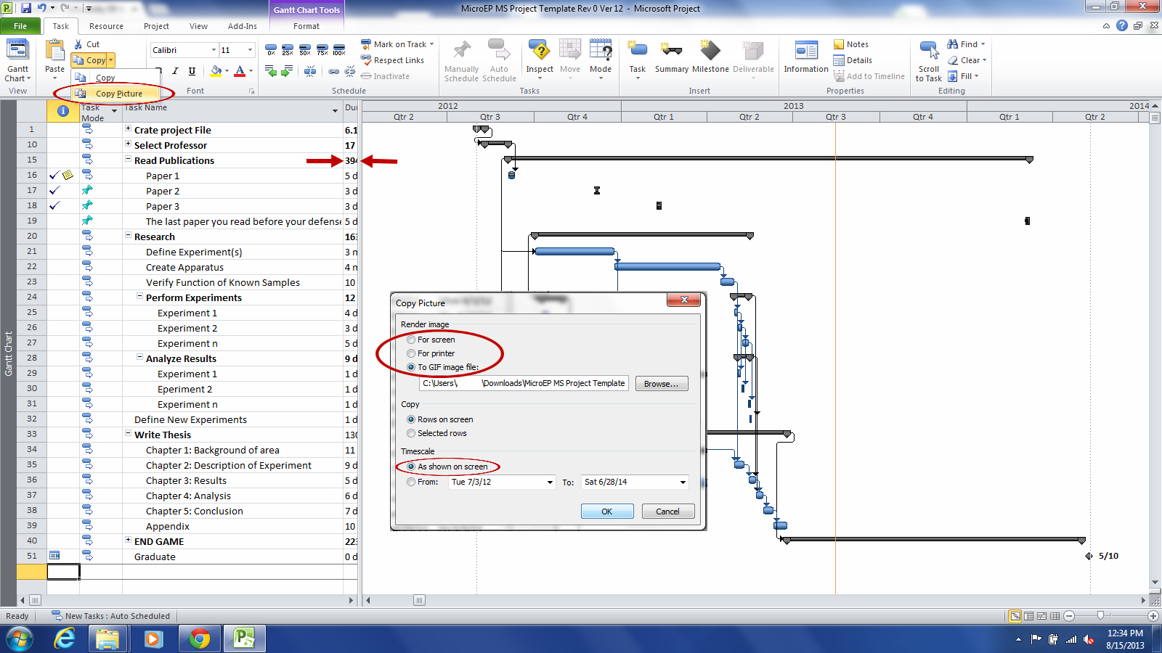
After inserting the gif file as a picture you can modify the image by rotating it so the top of the Gantt chart is toward the left side of the page. You can then expand the length of the inserted image to completely fill the page from the top to bottom margins (note that you may have to reduce the number of task lines in the image to accomplish the length expansion without violating the left and right margins.

References

- Ken Vickers, “MicroElectronics-Photonics Program Produces Great Engineers,” Journal of BS, Vol. 6, pp. 157-176, 1999.
- Ron Foster, “I Love My Chevelle,” Engineers and the Cars They Drive, 2002, p. 47-51.
- Ken Vickers, “My Recommendations for Students,” 15th Annual Conference on Long-Winded Speakers, Vol. 8, pp. 34-589, 2004.
- Renee Hearon, “Persuading Students to Turn in Their MS Project Files and Resumes,” Private Communications,1998.

Appendix A: Description of Research for Popular Publication

The MicroEP Project Files
Students Express Aversion to MS Project
By Anonymous Author

Every semester new cohorts enter the ranks of the University of Arkansas’ MSEN graduate program, and every semester students complain about being threatened with stonings, disembowelments, and even beheadings if they do not continually update their Microsoft Project files. MSEN Program Director Ken Vickers contemplates the source of this dislike and utter loathing of MS Project.

THE PUNISHMENT BEGINS In the year of our supreme despot “Vickers the Vicious” MCMXCVIII, Ken Vickers, a former Texas Instruments manager, devised a graduate program unbound by the conventions of conservative, humdrum engineering and physics. As part of the provisions set forth by Vickers, students would be required to plan their research using Project from Microsoft Corp.

Fortunately for the MSEN student community, the wisdom of the esteemed program managers was heeded despite the trepidation of incoming and senior students alike. Imagine the surprise of MSEN alumni as they entered the workplace only to find that project planning was not only expected – but also useful, appreciated, and led to personal success and financial rewards almost beyond comprehension.

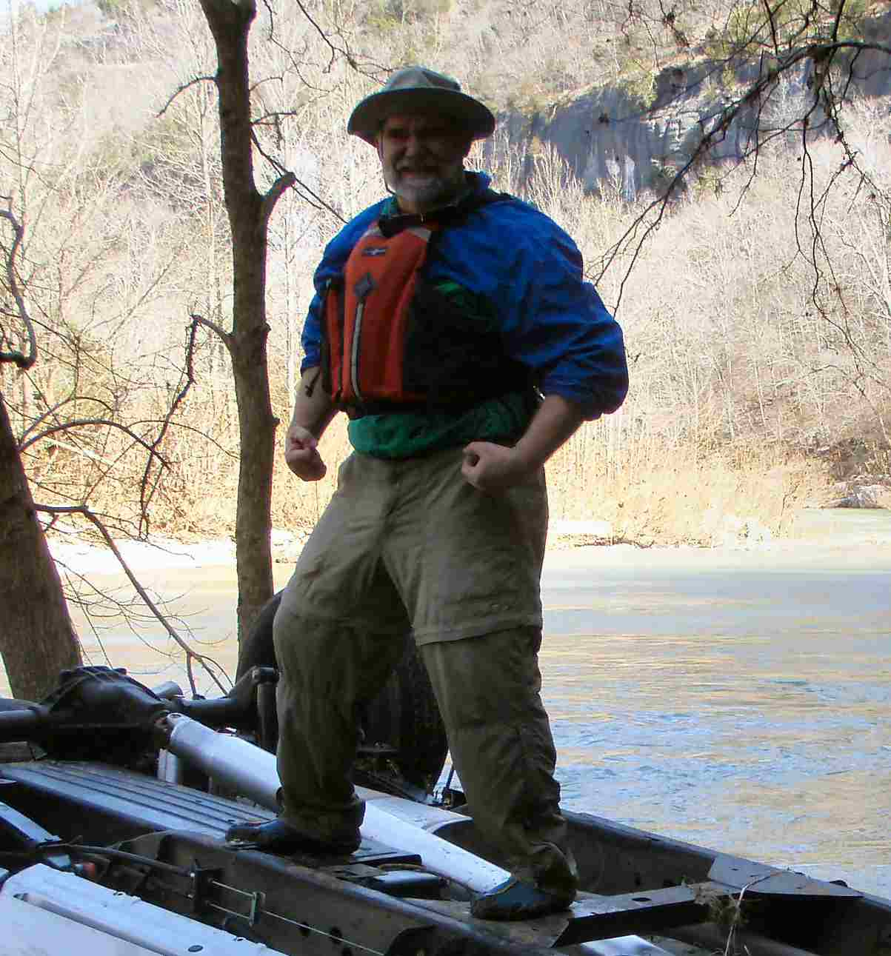
As Cohort 2 alumni Gary Russell noted in an email after a couple of years on the job, “…besides MSProject, which I use on a daily basis and have not yet managed to escape.” This example of the ringing endorsements, yea even testimonials, from alumni of extreme personal pleasure derived from the use of this particular software tool has served to strengthen the resolve of the MSEN management team to continue leading the Cohorts in acquiring mastery of both project management technique and Microsoft Project software!
Figure 1: Vickers captured in victory dance after first "introduction to Microsoft Project" training session for a new Cohort

When asked what he finds most satisfying from this particular emphasis of the MSEN graduate program, Vickers replied, “While seeing the developing skill of the students is indeed satisfying, the real pleasure comes from being able to watch the students’ reactions to this software training – as this training is the closest legal thing to hazing that I could implement that would still be allowed in the University environment.”

Attempts to reach the University of Arkansas’ Ombudsman for comment were unsuccessful.

Appendix B: Executive Summary of Newly Created Intellectual Property

The following list of new intellectual property items were created in the course of this research project and should be considered from both a patent and commercialization perspective.
- A method for measuring a new physical property of matter, which has been named “Kelleyism” and is measured in units called “Matts”.
- A device which utilizes a film with values of 10-100 Matts to produce an effect that appears to a lay person as anti-gravity, but in reality is gravity nullification.
- An apparatus that utilizes the Kellyistic devices of item (2) that is a personal wheelless transportation device reminiscent of a motorcycle frame with horizontal flat discs in place of the normal vertically oriented tires.

Appendix C: Potential Patent and Commercialization Aspects of Listed Intellectual
Property Items

C.1 Patentability of Intellectual Property (Could Each Item be Patented)

The three items listed were considered first from the perspective of whether or not the item could be patented.
- The new material property of Kellyism can not be patented. However, the method developed in this research to measure Kellyism can be patented. It is unclear at this point if other direct or indirect methods exist that could also measure Kellyism, especially in the Matt ranges needed for useful devices and apparatus.
- The devices created in doing this research to show proof of concept can be patented, as they are both unique and non-obvious to one skilled in the art. In fact, since the art itself was non-existent prior to this research (with the exception perhaps of the “Back to the Future” movie series) almost anything applying the Kelleyistic nature of materials is by definition non-obvious to one skilled in the art.
- The apparatus utilizing the devices of item (2) can be patented; as such an apparatus has never been reduced to practice. It might be argued that conceptual renditions of similar flying personal transportation are widely available in both science fiction literature and video entertainment venues. However, these have been non-functional apparatus and could not be considered prior art. It should also be noted that the two disc apparatus demonstrated as part of this research is only a narrow illustrative example of a wide class of lifting apparatus utilizing a plurality of Kelleyistic discs, no less than one but not limited except by size of the apparatus and the output of the power supply.

C.2 Commercialization Prospects (Should Each Item Be Patented)

The three items listed were then considered from the perspective of whether or not the item should be patented.
- The method for determining the Mattistic value of Kelleyistic materials should be patented. It is anticipated that there will be significant commercial demand for instruments based on this method, as research in null gravity may have additional applications other than in transportation apparatus.
- The specific device should be patented as it is the only demonstrated effective way to harness the Kelleyistic properties of materials at this time. Other devices were indicated as being less effective and efficient during the research, and these alternative approaches should also be patented to prevent commercialization competitors with high-volume, low-cost manufacturing capabilities (such as the infamous, evil-empire Harley-Davidson company) from creating functional apparatus based on these inferior devices – but at a lower cost with the same gravity nullification capacity.
- This apparatus should be patented, probably by a team of about fifty top patent lawyers from the US and thirty or forty from other countries. It will wipe out multiple multinational corporations, and will probably have millions of people trying to find ways to work around everything patented that was created in this research project.

C.3 Possible Prior Disclosure of IP

The following items were discussed in a public forum or have published information that could impact the patentability of the listed IP.
- This newly discovered physical property of matter and the associated measurement technique of that property have not been discussed in any forum, barring the previously mentioned “Back to the Future” conventions.
- The device created that makes use of Kelleyism has not been discussed in any forum.
- The flight apparatus has not been discussed in any forum, but bear some similarity to apparatus discussed in US Patent 7,182,295 “Personal flight vehicle and system” issued February 27, 2007. The abstract for the patent is as follows,
“Various methods, apparatuses, and systems in which an electric-energy lifting panel levitates a user secured to the electric-energy lifting panel. The electric-energy lifting panel includes a first capacitive plate and a second capacitive plate having different geometric dimensions to generate a net-directional force. An ion conditioner ion enhances air around the first capacitive plate and the second capacitive plate.”
While the apparatus does have similar flight attributes to this IP, it seems that the method of propulsion removes this from direct patent conflict.
Appendix D: Broader Impact of Research

D.1 Applicability of Research Methods to Other Problems

When the applicability of this research approach to other areas was considered it was found that the basic philosophy of the research could be applied elsewhere. The primary philosophy used in this research was to enjoy the scenery while still paying attention to the research path. The original research topic of this thesis was “How to Melt Materials in a Way to Simulate Peanut Butter Consistency”. While working on a method of melting it was noticed under certain laboratory conditions (local midnight under a full moon, 98.2564% relative humidity, and 27.6 hours prior to a PhD candidacy exam) that the beakers of partially melted materials floated off the hot plate. Noticing this somewhat anomalous event did lead to the discovery of Kelleyism (although peanut butter consistency was not ever accomplished during this thesis work).

D.2 Impact of Research Results on U.S. and Global Society

While no impact on such things as population redistribution has yet to be observed (as there is only one prototype apparatus in the world right now), a change in population density in all communities would not be an unexpected result of the release of this thesis. It is also anticipated that all companies manufacturing or providing wheel-based vehicle services would be driven instantly out of business upon announcement of this research. This will probably have a ripple effect that could lead to total social upheaval, mass population migrations, and utter chaos in most local, state, and national governments. For this reason, a method for instantaneous global knowledge distribution of this thesis’ contents should be considered.
A separate impact of widespread implementation of transportation apparatus based on this research would be sharply increased mid-air collisions. An increase in medical personnel trained in trauma injury management may be indicated.

D.3 Impact of Research Results on the Environment

This research method does not have any adverse environmental impact from the manufacture of the materials and devices. The creation of apparatus utilizing the devices could utilize such items as lead-based paint (especially if the nefarious Harley-Davidson company attempts to appropriate our ideas without compensation), which would adversely impact the consumer if the apparatus is partially or fully ingested.

Appendix E: Microsoft Project for MS MicroEP Degree Plan

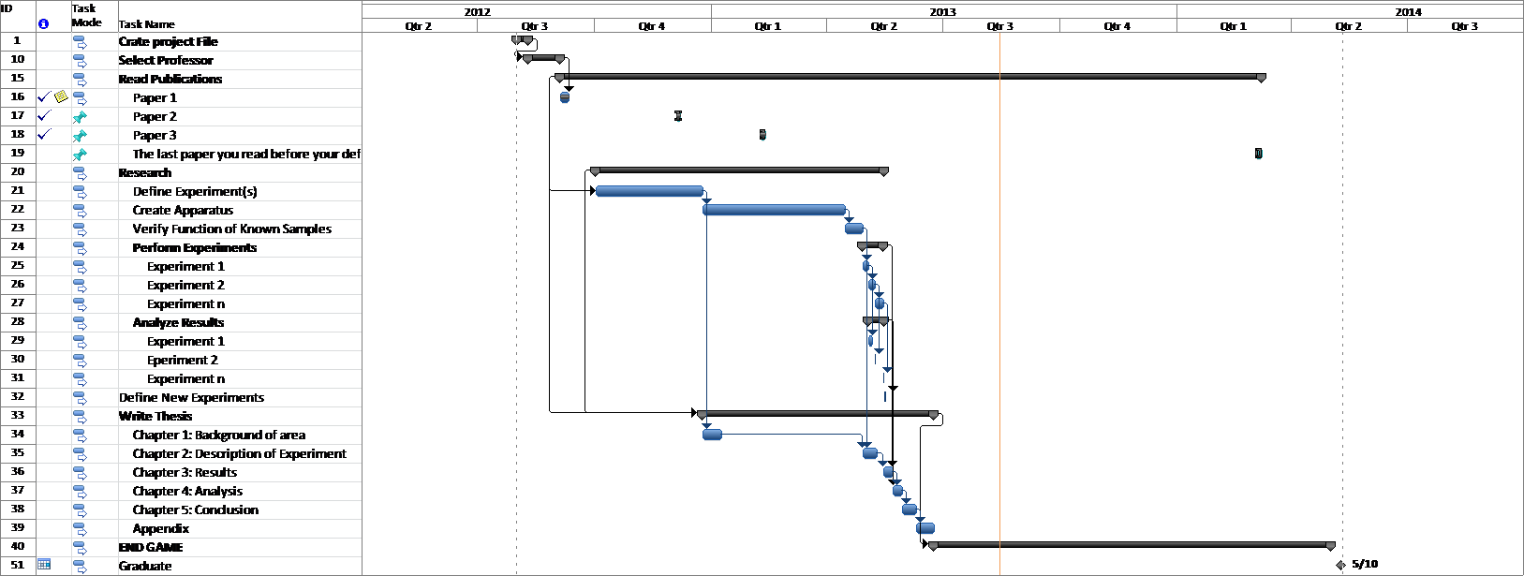
Appendix F: Identification of All Software Used in Research and Thesis/Dissertation Generation

Computer #1:
Model Number: Dell Dimension 8300
Serial Number: 8654FG32
Location: PHYS134
Owner: Prof. Ken Vickers
Software #1:
Name: Microsoft Office 2007
Purchased by: UA Physics Dept.
Software #2:
Name: MATLAB v6.5
Purchased by: Prof. Ken Vickers
Software #3:
Name: Adobe Acrobat Professional 10.0
Purchased by: University of Arkansas Site License

Computer #2: Continue until all computers and software are listed.

Appendix G: All Publications Published, Submitted and Planned

